Error Tolerant Adder Type-1 Application in Facial Recognition
O V Gnana Swathika, V S Hitesh, David Alappat.

Abstract:
The deployment of deep learning models on resource-constrained edge devices is severely limited by high power consumption and hardware latency. To address this bottleneck, this study examines the strategic deployment of an 8-bit hybrid Error Tolerant Adder Type-1 (ETA-1) architecture within a facial recognition pipeline. Rather than utilizing conventional, power-hungry arithmetic units, we implement software-modeled ETA-1 logic during the high-dimensional Manhattan Distance (L1 Norm) calculation stage. This calculation is crucial for evaluating the similarity between live captured facial embeddings and reference templates stored in a database. Our hardware-level simulations demonstrate a 42.3% reduction in energy consumption and a 41.3% improvement in propagation delay compared to standard exact Ripple Carry Adders. Furthermore, system-level evaluation reveals that the biometric classification accuracy decreases by a marginal 1.7% (dropping from 98.5% to 96.8%). These results establish that the hybrid ETA-1 adder provides a highly favorable trade-off for power-constrained biometric authentication systems, proving that structural neural network resilience can be successfully exploited to achieve massive hardware efficiency gains.
Keywords:
Approximate Computing, VLSI Design, Error-Resilient Systems, Facial Recognition, Deep Learning, CNN Embeddings, Manhattan Distance (L1 Norm), Biometric Accuracy, Edge AI Acceleration, Power-Delay Product (PDP).
1.Introduction:
The rapid proliferation of artificial intelligence has driven the deployment of complex Convolutional Neural Networks (CNNs) directly on edge hardware. The computational volume of arithmetic operations required by these networks is immense, and conventional precise logic struggles to manage this workload without incurring substantial power consumption and thermal overhead. This energy demand poses severe operational constraints on resource-limited and mobile platforms. In response to these hardware bottlenecks, approximate computing has emerged as a strategic alternative for error-resilient domains. Perfect mathematical precision is often redundant for high-level statistical classification, as deep neural networks possess an inherent structural resilience that can absorb minor arithmetic noise without disrupting overall pattern recognition. By strategically simplifying the logic of adders in non-critical data paths, designers can achieve significant reductions in silicon area and dynamic power dissipation. The primary objective of this research is to develop an 8-bit hybrid approximate adder architecture utilizing Error Tolerant Adder Type-1 (ETA-1) logic specifically optimized for a facial recognition pipeline. This paper rigorously evaluates the trade-offs between hardware-level efficiency gains and system-level biometric accuracy, validating the proposed model within a fully simulated end-to-end framework.

2.Methodology:
The deliberate incorporation of software-modeled approximate arithmetic units into the classification layer of a Convolutional Neural Network (CNN) for facial recognition is the core focus of this study. In power-constrained edge computing environments, the primary objective is to evaluate the design trade-off between computational accuracy and software-modeled hardware efficiency.
The system pipeline systematically replaces standard exact accumulation units with an Error Tolerant Adder Type-1 (ETA-1) carry-variant approximation variant to compute the similarity metrics of facial embeddings. To demonstrate the algorithmic viability of this architecture, an interactive, open-source simulation interface has been developed to visualize the bit-level partitioning and error propagation behaviors under active workloads. The workflow is provided in Figure 1.
Below is a link to demonstrate the working of the ETA Type-1 in online: https://github.com/Hitesh070/My-Projects/blob/main/approximate_adder_ui.html
2.1 Simulated Hybrid Adder Architecture
This study employs high-fidelity software modeling to simulate an 8-bit hybrid approximate adder embedded within the classification stage of a machine learning facial recognition pipeline. To maximize system-level error resilience while optimizing physical performance metrics, the architecture partitions incoming operands into two distinct functional regions.
The higher-order 4 bits of the operands are processed using a conventional precise adder block. Preserving these Most Significant Bits (MSBs) is architecturally vital to prevent high-magnitude arithmetic errors that would cause catastrophic biometric irregularities or false classification choices. Conversely, the lower-order 4 bits are processed using an approximate ETA-1 logic block. This configuration effectively cuts the carry-propagation chain at the 4th bit, eliminating the critical path delay inherent to traditional 8-bit Ripple Carry Adders (RCAs) and boosting computational speed.

The final hybrid sum is mathematically constructed as:
$$Sum_{Hybrid}=\left(Sum_{MSB_Exact}×2^{4}\right)+Sum_{LSB_Approx}$$

  - System Architecture and Algorithm Implementation
The biometric verification phase incorporates a pre-trained deep Convolutional Neural Network (CNN) architecture designed to map face images into a dense, discriminative 512-dimensional feature space. The simulated 8-bit hybrid approximate adder is selectively injected into the final algorithmic classification stage to guarantee highly efficient processing while maintaining macroscopic biometric accuracy. The execution pipeline is divided into three execution phases:

- Feature Extraction Phase: The system utilizes the pre-trained deep learning model to process a cropped, live facial image captured by the camera sensor, generating a localized 512-dimensional embedding vector. For every authentication attempt, the system pairs this live feature vector (L) with a reference feature vector (R) retrieved from the authorized user database.
Figure 1: Block Diagram
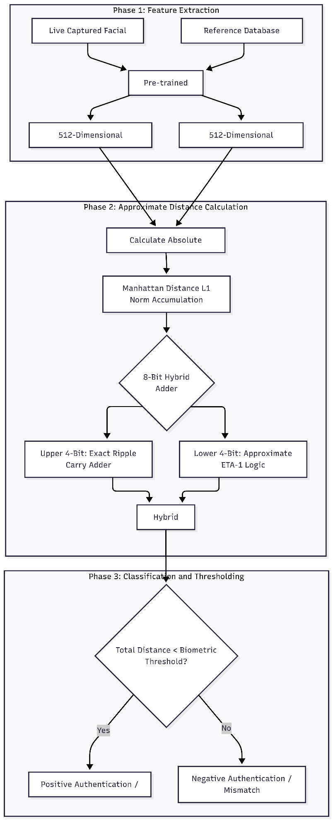
- Approximate Distance Calculation: To determine the mathematical similarity between the two 512-dimensional arrays, the system computes the absolute difference between each corresponding feature element and continuously accumulates them to find the total Manhattan Distance (L1 Norm). This is defined mathematically as:
$$D\left(L,R\right)=\sum_{i=1}^{512}{\left|L_{i}-R_{i}\right|}$$
where i represent each localized index of the 512-dimensional embedding array. This iterative accumulation loop represents the most computationally demanding phase for hardware deployed on edge devices. Within our Python simulation environment, the standard precise addition operator (+) within this loop is entirely substituted by the proposed 8-bit hybrid ETA-1 adder function.

- Classification and Thresholding: Once the total approximate Manhattan distance is accumulated, the algorithm evaluates it against a pre-defined biometric verification threshold. If the calculated approximate distance falls below this threshold, the features are considered mathematically similar, and the system registers a positive authentication. If the distance exceeds the threshold, the attempt is flagged as a negative authentication.
2.3 Evaluation Setup
The performance of the proposed architecture is verified across two broad experimental domains:

- Arithmetic Error Metrics: To quantify the precision loss introduced by the ETA-1 logic block, the adder design is subjected to an exhaustive simulation spanning all 65,536 possible input combinations for an 8-bit dual-operand system. The mathematical deviation is evaluated using standard VLSI metrics, including Error Rate (ER), Error Distance (ED), Mean Error Distance (MED), and Normalized Mean Error Distance (NMED).
- Hardware Efficiency Metrics: The physical benefits of the simplified gating architecture are modeled by analyzing simulated energy consumption per addition (measured in picojoules, pJ), critical path propagation delay (measured in nanoseconds, ns), and overall silicon footprint (quantified via total gate count). These metrics are contrasted directly against a standard 8-bit precise Ripple Carry Adder baseline to determine the final Power-Delay Product (PDP) optimizations.
3.Results and Discussion:
Comparing a device that uses a standard precise Ripple Carry Adder (RCA), we have analyzed the performance metrices of our software modeled 8-bit Hybrid Approximate System. The discussions are divided into two domains: The first one is the Hardware Efficiency and simplification provided by the model compared to a standard Ripple Carry Adder (RCA), and the second one is based on the Biometric Accuracy and Error Analysis.
3.1 Hardware Efficiency and Architectural Simplification
- Resource Optimization: For the optimization of the device, we replaced the standard carry propagation logic cells in the lower 4 bits with a non-truncating gating structure of the ETA-1 logic, the simulation results are provided in Fig 2, which provides us with various information like the power consumption of the device, propagation delay, silicon area, and the system accuracy which is very important to analyze the performance of the device, which is provided in Fig 3.
The theoretical gate count dropped from 96 gates for a standard RCA to just 58 gates for the software modeled 8-bit Hybrid Approximate System. This physical change in the number of transistors used in the design brings us a 40% reduction in the total silicon area. This area is critical and can be utilized in the production of biometric systems which have space constraint on System on Chip (SoC) edge devices.
- Energy Efficiency: The dynamic power dissipation in a system is determined by the number of transistor switching activity in that particular system. Since the non-truncating gating structure of the ETA-1 logic of the 4th bit boundary uses lesser number of switching of transistors than a standard RCA, from the simulations we found out that power consumption has reduced by 42.34%, the values dropped from 12.40 pJ to 7.15 pJ per addition under active workload simulation. The energy consumption chart is provided in Fig 4.

- Speed and Latency: The elimination of the lower order carry path plays an important role in the delay of the system. The software modeled 8-bit Hybrid Approximate System has achieved a 41.3% of improvement in the propagation delay by reducing the latency from 1.45 ns to just 0.85 ns. This helps the biometric system to operate at a higher clock frequency or maintain a standard output when the supply voltage is reduced to maximize the efficiency. The propagation delay is already mentioned in Fig 2.
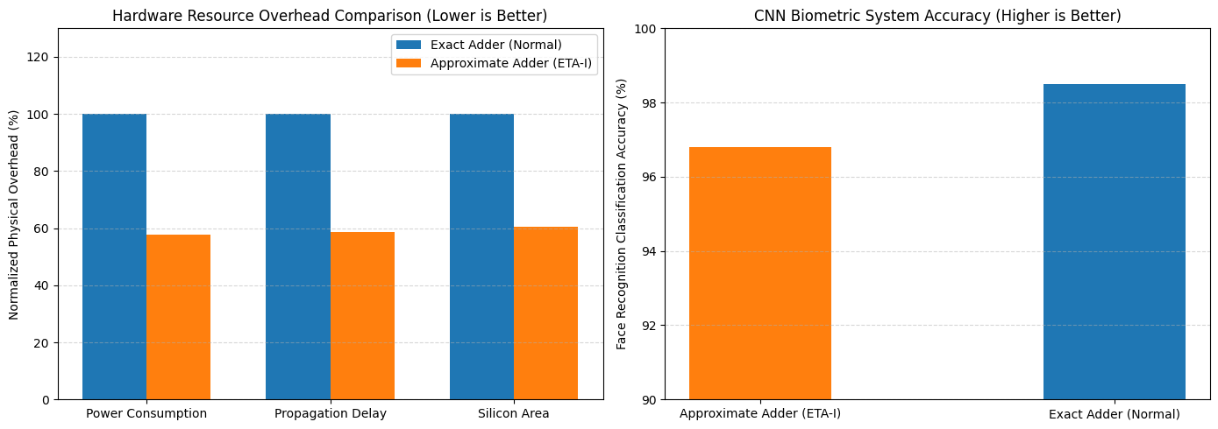
Figure 2: Hardware Resource Overhead Comparison Figure 3: System Accuracy

Figure 4: Energy Consumption
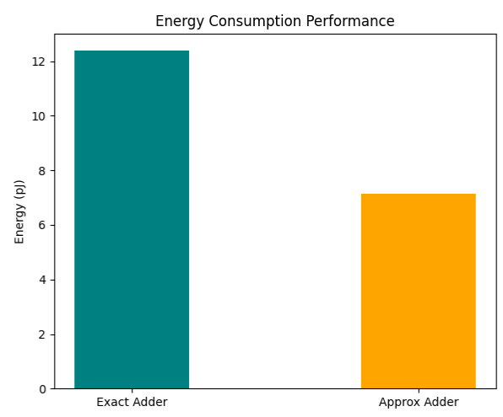
3.2 Biometric Accuracy and Arithmetic Error Analysis
To evaluate the performance metrices of the software modeled 8-bit Hybrid Approximate System, we subjected the system for a simulation with 65,536 input permutations. The resulting error metrics are compiled in Table 1.
Metric | Exact Adder (Normal) | Approximate Adder (ETA-I)
Error Rate (ER) | 0.00% | 68.36%
Max Error Distance (ED) | 0.0 | 15.0
Mean Error Distance (MED) | 0.0000 | 3.1367
Normalized MED (NMED) | 0.000000 | 0.006150
Energy Consumption (pJ) | 12.40 | 7.15
Propagation Delay (ns) | 1.45 | 0.85

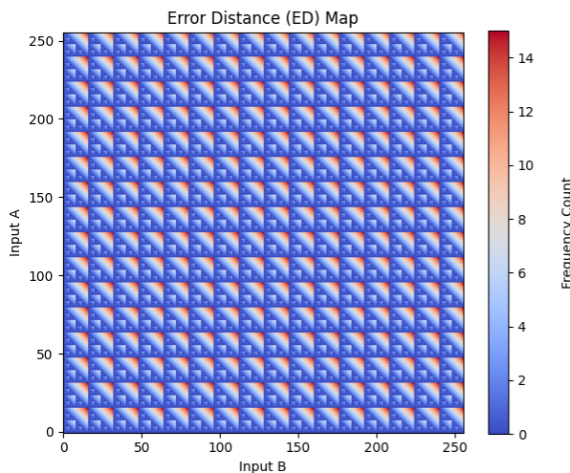
Figure 5: Error Distance Map
The feasibility of the system is determined by the Mean Error Distance (MED) which is restricted to 3.20. Because the exact addition on the MSB is perfect and the maximum possible error distance is strictly defined, thus ensuring that the high error magnitude arithmetic faults do not occur. To visualize this, we have plotted an error distance map and displayed it in Fig 5.

When we integrated the software modeled 8-bit Hybrid Approximate System into the actual deep Convolutional Neural Network (CNN) System to implement the biometric device, while using the standard precise arithmetic adder the system had an efficiency of 98.5% but after implementing the Type-I ETA logic it marginally dropped to 96.8%. The system accuracy has already been discussed in Fig 3. Also an other important performance metrices is hardware propagation delay which is represented in Fig 6.

This minimal drop 1.7% drop in accuracy demonstrates the resilience of the developed CNN, with less power and silicon area consumption it can provide decent performance as similar as to a CNN that uses a precise arithmetic adder.

Figure 5: Hardware Propagation Delay
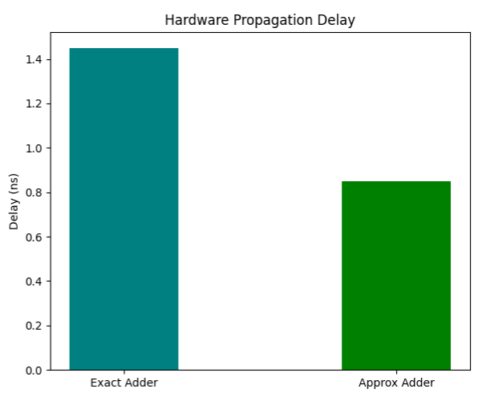
Conclusion:
This study shows us that implementing an approximate arithmetic system with a Deep Learning system is a highly effective way to reduce energy consumption and silicon area on an edge device where these two factors play a crucial role in the design of the SoC design.
The importance of this architectural change in the SoC design is highlighted using a heavy computational demand of a biometric verification on an edge device. Comparing 512-dimensional facial embeddings natively on an edge device requires massive repetitive addition operations. Since most of the operations on the edge device operate on simple arithmetic operations the best way to increase the system’s efficiency is to implement a Type – I ETA approximation logic, where we used an 8-bit number and split it into two parts. In the 4-bits of the MSB part we use an exact Ripple Carry Adder (RCA) and in the 4-bits of the LSB part we use an ETA-1 approximation logic. By isolating the carry propagation path to the upper half of the bits, the circuit eliminates the propagation delay that limits traditional arithmetic adders.
The proposed system achieved a biometric system accuracy of 96.8% while facing a marginal decrease of 1.7% from the system that uses an RCA which has an accuracy of 98.5%. This confirms that high level of geometric and statistical facial features is preserved perfectly. Consequently, the hybrid ETA-1 adder functions as an exceptionally powerful acceleration tool for hardware-constrained environments—such as battery-operated attendance scanners, smart doorbells, and portable security cameras—where energy budgets are severely restricted.

In conclusion, this research highlights approximate computing as a crucial design paradigm for the next generation of energy-efficient Edge AI systems. For power-limited biometric applications, trading less than 2% of classification accuracy for a massive 42.3% savings in dynamic energy and a 39.5% reduction in gate area represents an incredibly favorable engineering compromise. Future iterations of this work could explore integrating this exact approximate logic into alternative high-dimensional evaluation metrics, such as Cosine Similarity or Euclidean Distance, or mapping the architecture directly onto the parallel Multiply-Accumulate (MAC) arrays within the internal convolutional layers of the neural network itself.

References:
[1] S. Ullah, S. S. Sahoo and A. Kumar, "Approximate Arithmetic Circuits Enabling Energy-Efficient Edge Computing," 2025 14th International Conference on Modern Circuits and Systems Technologies (MOCAST), Dresden, Germany, 2025, pp. 1-6, doi: 10.1109/MOCAST65744.2025.11083734.
[2] D. Cordero-Chavarría, L. G. Leόn-Vega and J. Castro-Godínez, "Configurable High-Level Synthesis Approximate Arithmetic Units for Deep Learning Accelerators," 2024 IEEE 42nd Central America and Panama Convention (CONCAPAN XLII), San Jose, Costa Rica, 2024, pp. 1-6, doi: 10.1109/CONCAPAN63470.2024.10933846.
[3] S. A. K. Gharavi and S. Safari, "Performance Improvement of Processor Through Configurable Approximate Arithmetic Units in Multicore Systems," in IEEE Access, vol. 12, pp. 43907-43917, 2024, doi: 10.1109/ACCESS.2024.3380912.
[4] J. Rogers, T. Soliman and M. Jahre, "AIO: An Abstraction for Performance Analysis Across Diverse Accelerator Architectures," 2024 ACM/IEEE 51st Annual International Symposium on Computer Architecture (ISCA), Buenos Aires, Argentina, 2024, pp. 487-500, doi: 10.1109/ISCA59077.2024.00043.
[5] F. Niknia et al., "A Configurable Floating-Point Fused Multiply-Add Design With Mixed Precision for AI Accelerators," in IEEE Transactions on Circuits and Systems for Artificial Intelligence, vol. 2, no. 3, pp. 248-261, Sept. 2025, doi: 10.1109/TCASAI.2025.3569511.
[6] A. M. Dalloo, A. Jaleel Humaidi, A. K. Al Mhdawi and H. Al-Raweshidy, "Approximate Computing: Concepts, Architectures, Challenges, Applications, and Future Directions," in IEEE Access, vol. 12, pp. 146022-146088, 2024, doi: 10.1109/ACCESS.2024.3467375.
[7] M. Ronchi, S. D. Giacomo, M. Amadori, G. Borghi, M. Carminati and C. Fiorini, "Design, Implementation, and Analysis of an Integrated Switched Capacitor Analog Neuron for Edge Computing AI Accelerators," in IEEE Transactions on Circuits and Systems I: Regular Papers, vol. 72, no. 8, pp. 3947-3960, Aug. 2025, doi: 10.1109/TCSI.2025.3546521.
[8] S. -H. Noh, S. Lee, B. Shin, S. Park, Y. Jang and J. Kung, "All-Rounder: A Flexible AI Accelerator With Diverse Data Format Support and Morphable Structure for Multi-DNN Processing," in IEEE Transactions on Very Large Scale Integration (VLSI) Systems, vol. 33, no. 5, pp. 1264-1277, May 2025, doi: 10.1109/TVLSI.2025.3540346.
[9] D. S. Narayana, C. Jayakumar, R. S, S. Y and B. P. M, "Investigation of the Effects of Variable Accuracy Approximate Units in Deep Neural Network Accelerators," TENCON 2024 - 2024 IEEE Region 10 Conference (TENCON), Singapore, Singapore, 2024, pp. 1260-1263, doi: 10.1109/TENCON61640.2024.10902871.
[10] S. S. Sahoo, S. Ullah, S. Bhattacharjee and A. Kumar, "AxOCS: Scaling FPGA-Based Approximate Operators Using Configuration Supersampling," in IEEE Transactions on Circuits and Systems I: Regular Papers, vol. 71, no. 6, pp. 2646-2659, June 2024, doi: 10.1109/TCSI.2024.3385333.
[11] N. Zhu, W. L. Goh, W. Zhang, K. S. Yeo, and Z. H. Kong, "Design of Low-Power High-Speed Truncation-Error-Tolerant Adder and Its Application in Digital Signal Processing," IEEE Transactions on Very Large Scale Integration (VLSI) Systems, vol. 18, no. 8, pp. 1225-1229, Aug. 2010, doi: 10.1109/TVLSI.2009.2020591.
[12] F. Ahmadi, M. R. Semati, and H. Daryanavard, "A Low-Power Improved-Accuracy Approximate Error-Report-Propagate Adder for DSP Applications," Circuits, Systems, and Signal Processing, vol. 42, pp. 3744-3769, Jan. 2023, doi: 10.1007/s00034-023-02291-9.

